A Combined use of Hydraulic and Hydrological Model to Characterise Channel Hydro-Geomorphology of a Tropical River Basin of West Bengal, India

Swetasree Nag1

1 School of Water Resources Engineering, Jadavpur University, Kolkata, West Bengal, India

<https://orcid.org/0000-0002-5079-6559>

Sayak Karmakar1

1 School of Water Resources Engineering, Jadavpur University, Kolkata, West Bengal, India

Malabika Biswas Roy2

2 Department of Geography, Women’s College, Calcutta, Kolkata, West Bengal, India

[https://orcid.org/0000-0001-5063-0068](https://orcid.org/0000-0001-5063-0068?lang=en)

Pankaj Kumar Roy1*

1 School of Water Resources Engineering, Jadavpur University, Kolkata, West Bengal, India

<https://orcid.org/0000-0003-2225-7360>

*Corresponding author. e-mail: [pankaj.kroy@jadavpuruniversity.in](mailto:pankaj.kroy@jadavpuruniversity.in)

**Abstract**

The present study aims to examine the changing hydro-geomorphological properties of the Mayurakshi River located in a plateau fringe region in Jharkhand and West Bengal. The field investigation of 14 cross-sectional sites has been conducted during post-monsoon season of 2021 to determine important geomorphic parameters such as channel depth, width, bank height, hydraulic radius, wetted perimeter, etc. Post-processed Kinematic Survey (PPK) and Current Meter tool has been used to measure the river bed profile and channel velocity respectively, to obtain more accurate locational information. A key objective of this paper is to compare field observed discharge data with selected hydraulic and hydrological models in order to determine how to estimate the amount of lean period flow within a section of a tropical river such as the Mayurakshi River in a scientifically accepted and cost-effective manner. Two important geomorphic based methods have been used here to calculate discharge amounts: Manning's equation and Kinematic Wave Parameter (KWP). The study reveals that the hydraulic method of Manning's equation can provide a better discharge estimate than the hydrological method. Furthermore, fragmented flow patterns, human intervention in active riverbed areas through sand mining, dam construction and barrage installation hinder the free flow of the river, which causes inefficient discharge and higher channel efficiency across the studied stretch.

**Keywords** Channel geometry, Flow pattern, Manning’s equation, Kinematic wave parameter (KWP), Differential Global Positioning System (DGPS) survey

**Acknowledgement**

Authors would like to express their sincere thankfulness to Survey of India, Government of India, for providing relevant topographical maps of the study area. Authors are also very much grateful to Mr. Soumyajyoti Mandal, Application Engineer of AllTerra Solution LLP, for his continuous guidance throughout the study of DGPS survey. In addition, authors also acknowledge the research scholars and the computer laboratory of School of Water Resources Engineering, Jadavpur University for providing the necessary facilities to carrying out the present study.

**1 Introduction**

A series of cross profiles reveals the fundamental hydro-geomorphological behaviour of a channel. The cross-section of a channel is function of its shape, size, flow, sediments that are moved through the section and deposited around the river bank (Leopold et al. 1964). The cross-section of a natural channel is characterised by irregularly outlined width, mean flow depth and a volume of discharge (Swamee 2000), which are assumed to get balanced with the underlying topography to form a stable reach irrespective of the scour and fill of river bed (Richards 1982). The study of channel geometry and the hydro-geomorphological behaviour may be monitored as a key concern for the scientific management of a river health (Lord et al. 2009; Singh 2003). In river hydraulics, the geometry of a cross section changes more frequently than a longitudinal profile. Any alteration in water discharge or sediment flow induces a noticeable change in channel geometry. Such changes are mainly instigated by the human intervention on river bed. Construction of various civil structures like dam, barrages, rail or road bridges, creation of temporary nala’s for irrigation purposes and excessive sand extraction from the active channel are the major catalyst behind the degradation of channel geometric properties resulting channel in-efficiency to carry enough water for a long run. Channel efficiency is largely dependent on the channel adjustment. In recent time, controlled or human regulated flow pattern is very much observed across the world. Most of rivers are being impounded with dam and barrages, which are not able met the sustainable development strategies (Hoque et al. 2022). Unfortunately, the main flow of river is now maintained within a narrow active channel area. River loses its natural flow due to the construction of water holding structures and also disturbed the movement of sediment, nutrient to the downstream on which the fluvial community depends (Mitra and Singh 2018; Mc Manamay and Bevelhimer 2013). Not only the controlled flow, scouring activity near the dam area generate a huge aggradation of sediment which may chock the downstream channel width significantly (Petts 1979; Williams and Wolman 1984).

In Ganga Bramhaputra Delta, the alteration in channel geometry due to anthropogenic intervention is well documented. Pal (2016) discussed the changes in channel morphology due to construction of Massanjore Dam and Tilpara Barrages in the Mayurakshi River. Ghosh and Guchhait (2016) noted the gradual shifting in flood duration during the post dam period of Damodar River. Moreover, the effect of post Farakka Barrage Project on the Bhagirathi Hugli River is worth mentioning. Mistry (1972) documented the problems of ship navigation due to the growth of mid-channel bar near the port area. Besides this, Basu et al. (2005) studied the changing nature of channel shape from meander to straight so as to maintain its perennial nature of flow throughout the year.

All the studies stated above indicates the channel hydro-geomorphological changes due to various constructional activities on the river bed. Estimation of river discharge is a major component of river hydraulics mainly when the understanding of its spatio-temporal dynamism is unacquainted to ourselves. The measurement of available surface water resources and the temporal heterogeneity of flow magnitude, frequency both during peak and lean flow period is crucial for the assessment of flood or drought like situation under changed climate scenarios (Xu et al. 2018). Rivers with such civil structures like dam or barrages, have their own gauge stations to monitor and document the daily records. But in West Bengal, most of the rivers are ungauged due to some environmental or financial limitations or rivers having monitoring station does not maintain the data properly. However, the direct measurement of river discharge using traditional gauging system or to via installing instrument are some points not suitable in remote or inaccessible areas along the river reach and thereby various indirect methodologies are becoming useful and feasible. Numerous studies have already been done for estimating the discharge amount in relation the channel geometric properties using various indirect methodologies like application of Unmanned Aerial Vehicles (UAVs) (Yang et al. 2019), remote sensing-based methods (Bjerklie et al. 2003; Getirana et al. 2009) etc. Tabata and Hickin (2003) used the ‘inter-channel hydraulic geometry’ model on Columbia River (Canada) and observed the changes in channel discharge capacity due to alteration in channel flow pattern. To assess the potential for reliable lean season flows in the San and Barah watersheds of Orissa, Pandey and Ramasastri (2003) applied various flow duration curve methods using daily/weekly/monthly discharge data. Above all, an accurate measurement of river hydraulics (width, depth, slope etc) from filed survey and compare the result with various multi-variate open channel flow equation gives the better output in discharge estimation (Sichangi et al., 2016).

The present study examines the changes in the hydro-geomorphological properties of the Mayurakshi River channel. Currently, Massanjore Dam and Tilpara Barrage are the only river gauges measuring the inflow and discharge of water from the dam each day. This study attempts to fill the gap of insufficient stream flow databases for sparsely gauged river basins (e.g., Mayurakshi River), by choosing 14 cross-sectional sites to illustrate channel geometry and the nature of lean period flow velocity and discharge scenarios. Hence, the study aims at estimating lean period discharge using two classical hydraulic and hydrological algorithms and validating the calculated values against field observed discharge data through RMSE analysis. Nevertheless, this study will ensure the benefit of field work besides the usage of such established numerical methodologies for estimating the hydraulic properties of a channel. The output of such research work will not only bring interests to the local stakeholders, but also make a significant contribution to the international science.

1. **Materials and Methods**

**2.1 Study Area**

Mayurakshi River is an important western tributary of Bhagirathi River which drains from the region of Jharkhand to the Bengal plain area. It covers an area about 5325 sq. km having a longitudinal extent of 86°84’–88°22’ E to latitudinal extend of 23°64’–24°62’ N. This 288km long river makes some important tributaries on the both side of its flowing route like Dhobi, Motihara, Tepra, Matihara, Bhurbhuri, Siddheswari, Bhamri, Pusaro, Main channel, Bara Nadi, Kushkarini and Kuya river. Since this river lies within a zone of tropical environment (Roy 2013), the major source of flowing water is the down pouring huge monsoonal rainfall from the upper part of the plateau region. The Maximum amount of rain occurs during the month of June to October having a mean annual rainfall of 1400 mm (Chaudhury 1966). On the contrary, during dry season, almost no flow condition prevails in every stretch of the river making it non-perennial in nature. Despite of this, installation of major anthropogenic civil structures like dam, barrages making the natural flow of river more controlled (Islam and Sarkar 2020). Adding to this, some other unscientific activities like excessive sand mining, creation of temporary Khals /Nalas on the river bed, are also exaggerate the problems of channel deformation by altering the channel geometry (Nag et al. 2022) (Fig. 2b)

Therefore, it is essential to examine the channel hydro-geomorphological properties and quantification of lean period river discharge of water to preserve the holistic benefits of Massanjore dam, Tilpara barrage and its adjoining canal system which is enjoyed by the mass population living in the floodplain area of the Mayurakshi River without hampering its future fluvial environment. To fulfil the objective of this research, 14 different cross profiles are selected from the upstream to downstream of the river Mayurakshi as shown in Fig. 1.

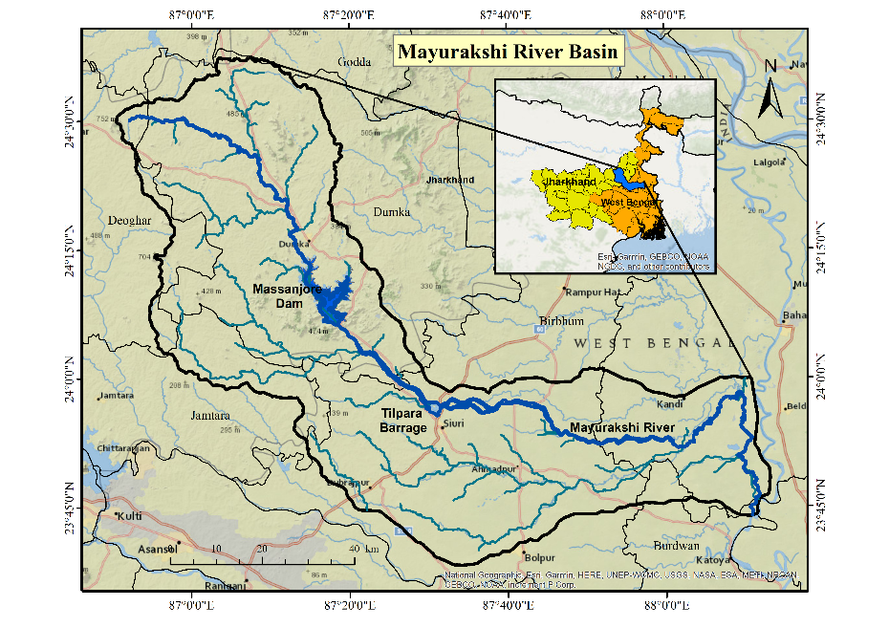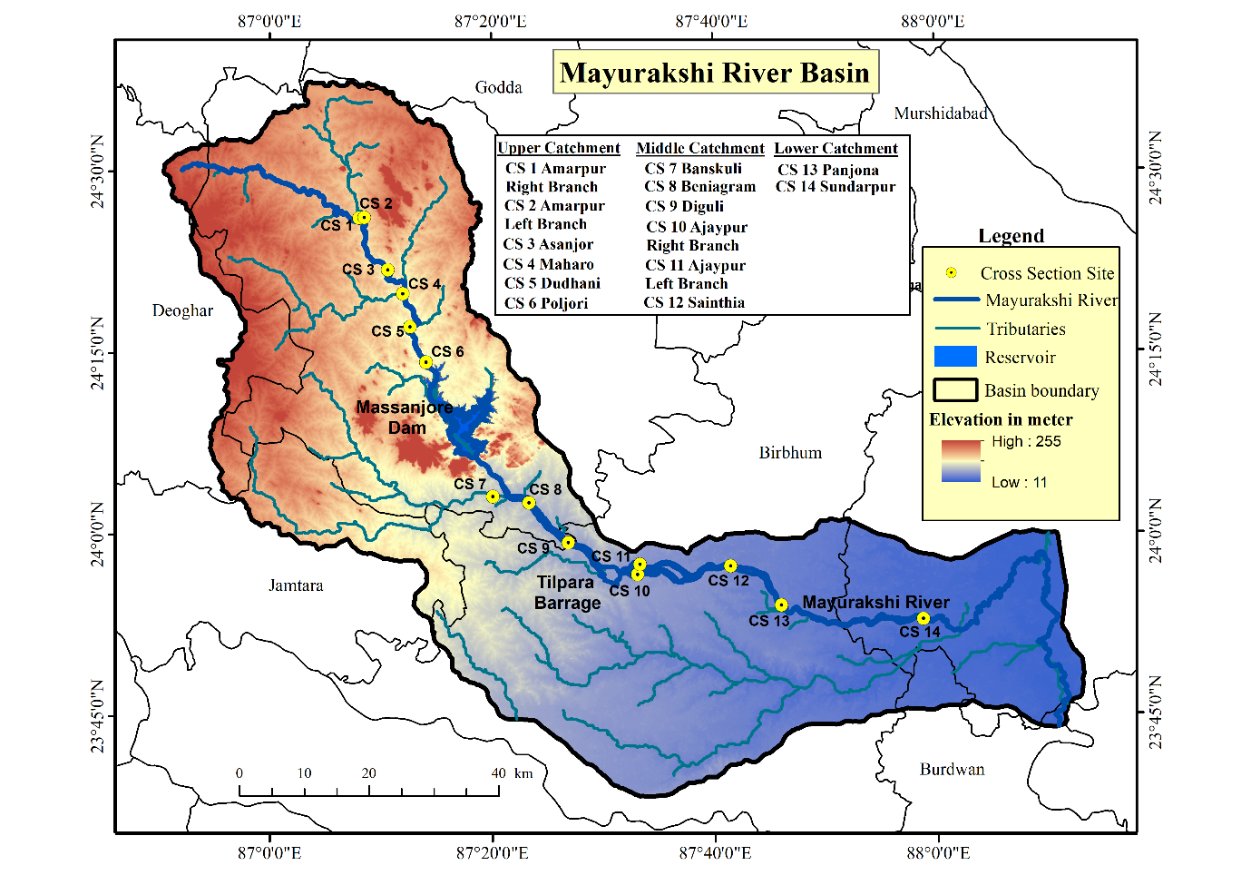

(a)

(b)

**Fig. 1** Location of the study area (a) Study area (b) Location of the cross-section sites over the Mayurakshi River Basin

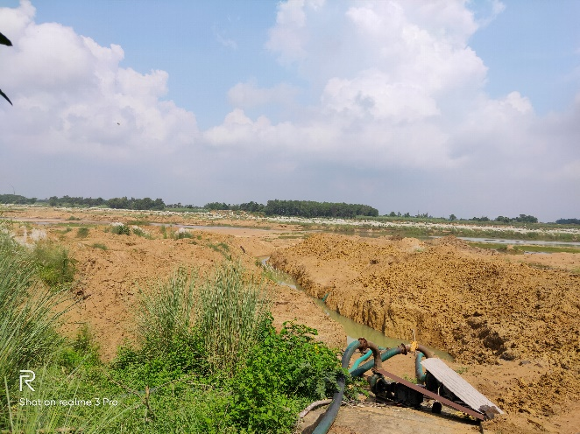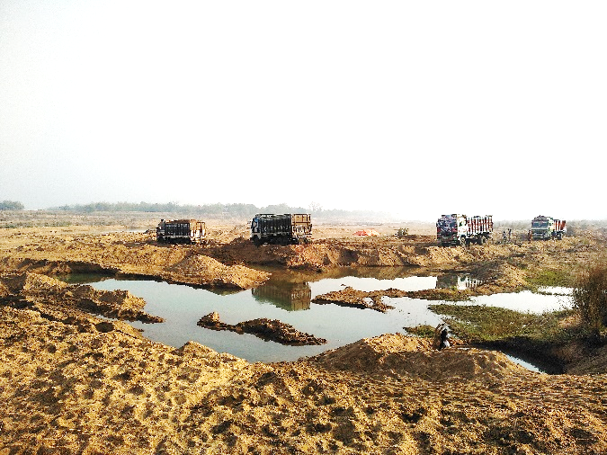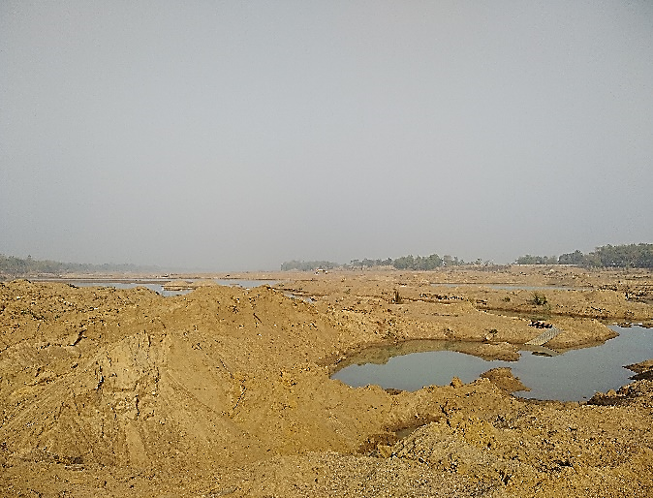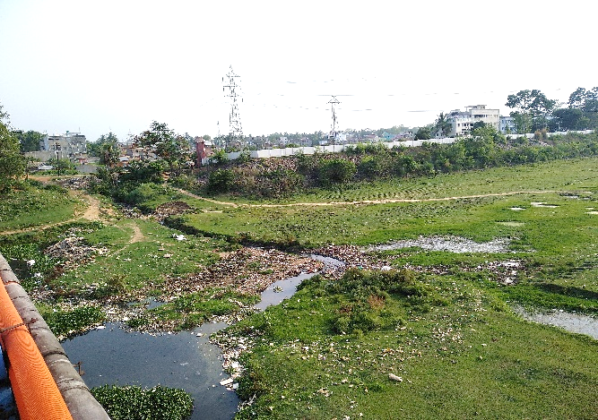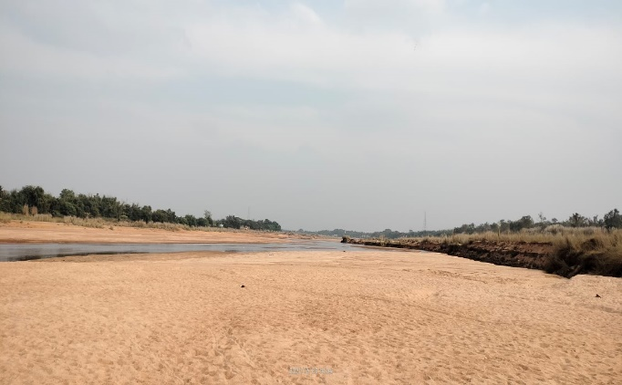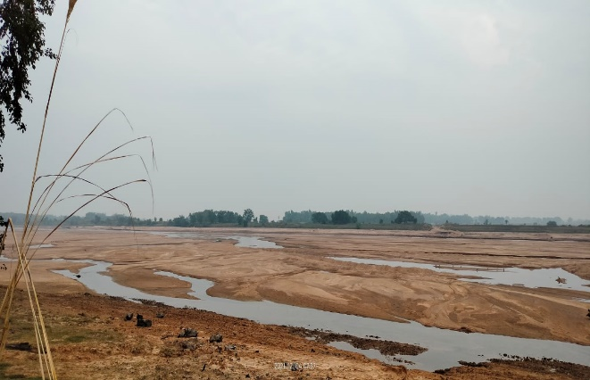

(a)

(b)

(c)

(d)

(e)

(f)

**Fig. 2** Human intervention on the Mayurakshi River (**a**)Excessive sand mining on active river bed (**b**) Construction of temporary khals/nalas for river lift irrigation (**c**) Channel shape and size deformation due to unscientific sand extraction from the river bed (**d**)Waste disposal directly to the river near Sainthia, Birbhum (**e**) No flow condition of river during dry season (**f**) Fragmented flow pattern in the downstream of Tilpara Barrage during dry season. (Source: Field Photographs, December, 2021)

**2.2 Data Collection**

The present research work is totally based on both primary and secondary data collection procedure. To study the channel cross sectional properties, authors have conducted an intensive field survey comprised of 14 different cross-sectional sites from the upstream of the river near Amarpur, Dumka, Jharkhand to the downstream of Sundarpur, Murshidabad during the month of December, 2021 (Fig. 3). The selection of each survey sites has been totally based on its locational importance in terms of sites near the upstream and downstream portions of dam and barrages, confluence point of important tributaries, channel closer to densely populated areas etc. The measurement of flow velocity in each section has been done using Current Meter instrument. It is regarded as most convenient instrument in hydrometry which measures at a point flow of water in a particular depth. (Subramanya 2008). Here, as most of the channels have a shallow depth (0.3m), the velocity has only been measured at just below the surface of the river water which gives the maximum flow velocity and after applying 1/7th power law function, the average velocity has been calculated (Knight et al. 2010). The measurement of flow velocity in each section has been done using Current Meter instrument (provide instrument name!). It is regarded as most convenient instrument in hydrometry which measures at a point flow of water in a particular depth. (Subramanya 2008). Here, as most of the channels have a shallow depth, the velocity has only been measured at just below the surface of the river water (at a distance of 0.05 to 0.15 times depth of flow from the free surface of flow (Some reference needed!)) which gives the maximum flow velocity and after applying 1/7th power law function, the average velocity has been calculated (Knight et al. 2010). Manning’s equation is applicable for uniform open channel flow. So, authors used average flow velocity for discharge calculation. Authors have also conducted a Differential Global Positioning System (DGPS) survey to measure the cross-sectional bed profile across the 14 selected sections of the river Mayurakshi. During this survey Post Processed Kinematic Survey (PPK) method has been applied by which the measured elevation data has been calibrated with reference to its closest permanent/local benchmark point using Trimble Business Centre software in post survey period. In this regard, three permanent benchmarks such as 144.96 m at Dumka Railway station, 67.44 m at Suri Railway station and 48.365 m at Sainthia Railway station have been used. Using that calibrated elevation data, each cross profiles have been constructed to depict the nature of channel geometry. The bank full height of each survey sites has been identified by visualising the demarcation of floodplain areas, water mark on the riparian vegetation zone and also from the local dwellers. Slope is another important parameter for the construction of cross profiles. It is the ratio of vertical gradient to its horizontal distance (Sen 1993). Here, to calculate the longitudinal slope, vertical gradient and equivalent horizonal distance of a particular channel has been measured using Google Earth Pro software. Other important channel features like channel depth, width, thalweg point have been measured with the help of measuring staff and tape.

In case of secondary data collection, Rainfall plays a major source of runoff generation over a basin area which contributes maximum amount of river flow and discharge accordingly. Here, maximum rainfall intensity (cm/h) has been taken into consideration for the estimation of discharge using Kinematic Wave Parameter (KWP) method, for which 31 days (December, 2021) rainfall data has been collected from the official website of Indian Meteorological Department (IMD) (www.imdpune.gov.in) having a resolution of 0.25*0.25 degree.

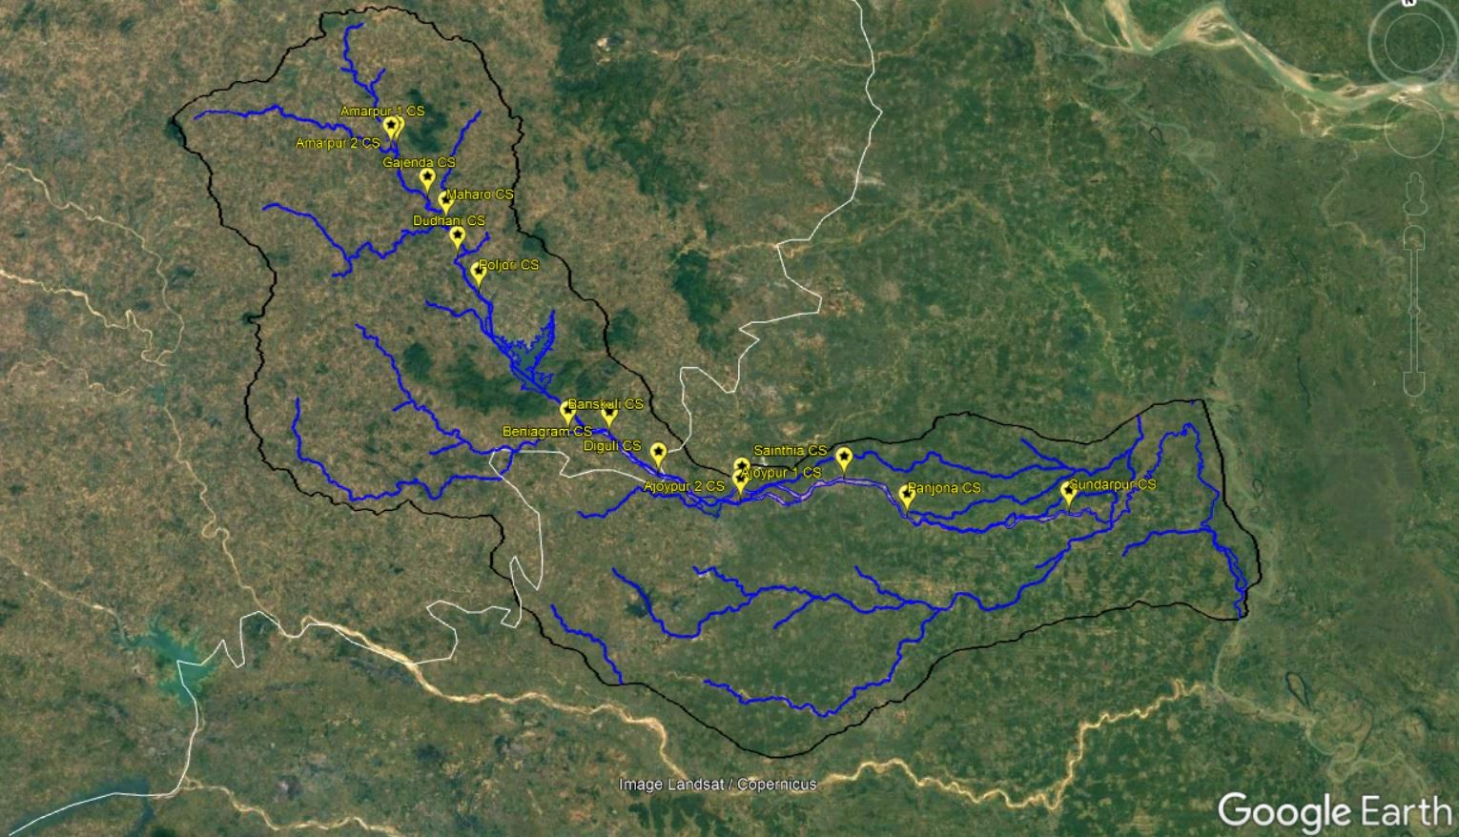

**Mayurakshi River**

**Kopai River**

**Bakreswar River**

**Kuya River**

**Siddheswari River**

**Tepra River**

**Motihara River**

**Dhobi River**

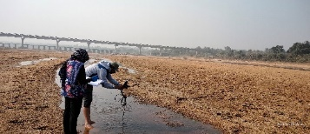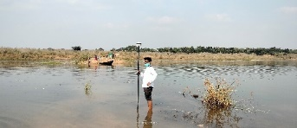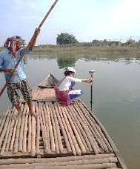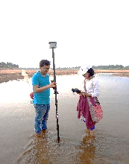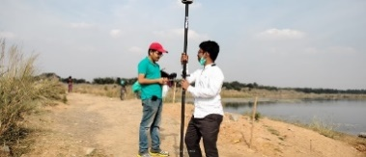

**Fig. 3** Google earth view of the cross-section sites with some field photographs over the Mayurakshi River

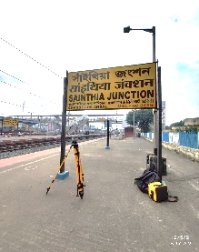

**2.3 Application of Manning’s equation for discharge estimation**

In this study, a combination of hydraulic and hydrological method of discharge estimation has been executed. The main aim behind this approach is to determine the scientifically accepted and cost-effective way for the calculation of river discharge during post field survey period.

Manning’s equation of flow is regarded as one of the most versatile and can widely be used in the analysis of open channel flow where channel bed roughness has been incorporated for the estimation of flow velocity (Summerfield 1991). This equation includes channel area, hydraulic radius, Manning’s roughness coefficient and longitudinal bed slope to determine the flow rate of the channel. The Manning’s equation defines the mean flow velocity (*v*) using the following equation

$v=\frac{k\left(R_{h}2/3*S^{1/2}\right)}{n}$ (1)

Where, k is the unit conversion factor (k=1 in SI unit and 1.486 in English unit).

Depending on the shape of the cross-sectional area, the hydraulic radius $(R_{h})$ and wetted perimeter ($P$) varies significantly. In this present study, the cross profiles of each channel in the Mayurakshi River shows a trapezoidal shape where the parameters like bottom width ($b$), width of the flow surface ($B$), wetted length along the sloped side ($l$), depth of the wetted portion ($y$) and the vertical angle of the sloped side (α) are shown in the Fig. 4a.

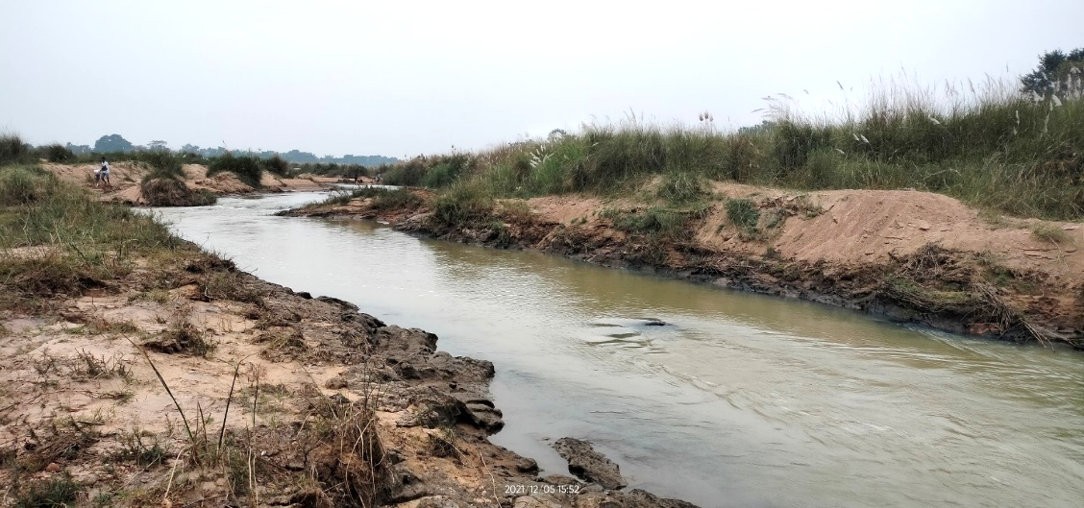

**b**

**B**

**y**

**zy**

***zy***

***l***

***l***

**Fig. 4** (**a**) Trapezoidal cross-section of Mayurakshi River

Yi+1

Yi

xi

xi+1

Zi

Zi+1

Water Level

(**b**) A schematic representation of an open cross-section channel

(a)

(b)

Hydraulic Radius $(R_{h})$ is an important criterion for Manning’s equation (Roy 2013). For a trapezoidal cross-section, hydraulic radius $(R_{h})$ is often expressed as

$R_{h}= A/P$ (2)

Where A represents cross-sectional area of flow. To calculate the area of flow, the entire river cross-section has been divided into n numbers of small trapezoids (Fig. 4b) and using the following trapezoidal rule (equation) the cross-section area of a channel has been determined

$A= \frac{\sum_{i=1}^{n}{(y_{i}+y_{i+1})(x_{i+1}-x_{i})}}{2}$ (3)

Where, yi represents water depth at iih point and xi represents distance of that point from the river bank.

And P is the wetted perimeter of a trapezoidal cross-section which can be expressed as

$P=\sum_{i=1}^{n}{\sqrt{{(z_{i+1}-z_{i})}^{2}+{(x_{i+1}-x_{i})}^{2}}}$ (4)

Where, zi represents the mean sea elevation of ith point.

Manning’s Roughness Co-efficient (n) is another major input for Manning’s flow calculation. It is a representation of channel friction or roughness applied to the flow by the bed surface (Manning 1891; Bloom 2009). The n value is often selected from the table as given by Chow (1964). In other way, numerous researchers have attempted to assign Manning’s roughness co-efficient in a natural channel by comparing it cross-sectional area, values sand particles in river bed profile etc (Chow 1959; Yen 2002). In this work, Manning’s roughness co-efficient has been derived from experiment and observation of equivalent sand roughness factor ($ks$) and friction factor ($f$) by comparing the Manning and Darcy– Weisbach equations. The following equation has been used to determine the Manning’s ‘n’ co-efficient (Chin 2020)

$\frac{R_{h}1/6}{n}=\sqrt{\frac{8g}{f}}$ (5)

Here, $f$ is denoted as the friction factor, which may be affected by the relative roughness of flow (smooth, transitional and rough). In our case of study, mostly rough flow conditions ($\frac{u_{*}k_{s}}{γ}>70$) prevail in every cross section of the channel, that has been determined based on the shear velocity ( $u_{*})$ and kinematic viscosity ( $γ)$ of water. Under rough flow condition, the friction factor of a trapezoidal channel can be estimated using the equation

$\frac{1}{\sqrt{f}}= -2\log_{10}\left(\frac{ks}{12R_{h}}\right)$ (6)

Here, $ks$ is defined as equivalent sand roughness which mainly varies with the bed particle size for their differential resistance power. The equivalent sand roughness has been determined by using the following formula (Raul Lopez et al.).

$ks=6.1D_{50}$ (7)

where, D50 is the mean particle size diameter of river bed material.

**2.4 Application of Kinematic Wave Parameter (KWP) for discharge estimation**

Kinematic Wave equation is an important rainfall dependent model where the amount of rainfall is being transformed into overland sheet flow and can be modelled as channel discharge when it reaches to its outlet (Mohammadi et al. 2012). On a trapezoidal channel, the generation of surface runoff is dependent on the slope of the flow path ($S$) and the amount of rainfall produce over an area. Therefore, an estimation must be made for the calculation of rainfall intensity ($i$) (cm/hr) over an area. considering these two criteria, Rodriguez-Iturbe et al. (1979) had demonstrated kinematic wave equation for the estimation of flow velocity ( $v_{kwp})$ using following equation

$v_{kwp}=0.665α_{Ω}^{0.6}(i*A)^{0.4}$, $α_{Ω}= \frac{S_{Ω}^{0.5}}{nB^{2/3}}$ (8)

Where, A denoted as drainage basin area in km2 and B is the mean flow width of the cross profile of the channel.

**2.5 Evaluation of model performance**

The calculation of Root Mean Square Error (RMSE) is a frequently used method to determine the level of accuracy or error function in any kind of dataset. Here, to identify the best method having least error between the observed field data and calculated data derived from different hydrological and hydraulic models, Root of Mean Square Error (RMSE) has been calculated. The equation for calculating RMSE is presented by

$RMSE= \sqrt{\sum_{i=1}^{n}{\frac{(\hat{y}i-yi)^{2}}{n}}}$ (9)

Where, $\hat{y}i$ is the predicted values and $yi$ is the observed values of the dataset.

1. **Results & Discussion**

**3.1 Channel hydro-geomorphological properties**

In this study, authors have selected 14 different locations from upstream to downstream of the Mayurakshi River. Elevation data has been collected using Differential Global Positioning System (DGPS). The purpose of this study is to construct channel cross profiles to depict the geometrical aspects of the river. As noted by Knighton (1998), the general shape of any cross-section is a function of its depth (d), width (w), area (A), velocity (v) discharge (Q), wetted perimeter (P), hydraulic radius (Rh), and its width depth ratio (w:d). Figure 5(a)-(n) shows the lean period channel configuration of the studied 14 cross profiles of different sites of the Mayurakshi River.

Authors have also tried to analyse the necessary hydraulic relationships between important variables that are discussed as follows-

**3.1.1 Width-Depth variation**

Table 1 shows important channel geometrical characters of the Mayurakshi River Basin. Width and depth of a channel are the most important structural variables which shows an interrelated nature of existence in every cross section of a channel (Mondal et al. 2018). Since width does not change with time, it is an independent variable. However, the depth of a channel varies based on its flow. In general, depth and width of a channel both are increases in downward but in case of Mayurakshi River, no definite trend has been observed among them. Nevertheless, the relationship between distance and depth (r2 = 0.42) and width (r2 = 0.62) shows a positive trend (Fig. 6a and b). However, an extending nature of river width (585 m) has been observed in an upstream location of the Mayurakshi River, which is unusual for a river in its upper reaches. Furthermore, a significant reduction in channel width has also been observed downstream of the Tilpara Barrage on Ajaypur's left and right branches of the Mayurakshi River. The massive discharge of water from Massanjore Dam and a controlled flow pattern are primarily responsible for the variation in channel width observed throughout the Mayuraskshi River. Likewise, an abrupt increase in channel depth has been observed in Sundarpur (7.31 m) because of the down pouring of river water from the tributaries like River Siddheswari, Kuya, accelerates the flow momentum of the river. A relationship has also been made between channel depth verses channel width and the result is not so satisfactorily high (r2 = 0.21) (Fig. 6c). The asymmetry in the structural variables of a river Mayurakshi indicates channel dynamism and a reduction in the efficiency of the channel to carry enough water.

**3.1.2 Variation in Total Channel Area and Flow Area**

Authors have considered both the area of the total channel and the cross sectional area of the water flow mainly to highlight the ratio of minimal presence of water during lean period with respect to its channel capacity during monsoon. The data shows a general increase in both channel area and flow area from upstream to downstream of the Mayurakshi River, showing a positive trend (r2 =0.48 in Fig. 6d) (r2 =0.56 in Fig. 6e). The ratio between the flow area and the total channel area (Table 1) also represents a scenario of differential nature of flow both in dry period to peak flow in monsoonal season in the Mayurakshi River.

**3.1.3 Variation in Hydraulic Radius (Rh)**

Hydraulic Radius is a measurement of channel flow efficiency that can control the amount of fluid discharge of a channel and also determine the ability to move sediments (Spark 1960). It is the ratio between cross sectional area with its length of wetted perimeter. This hydraulic mean depth can vary with the shape of the cross section. In a trapezoidal section, higher the value of hydraulic radius denotes an improved condition of channel efficiency because of the increased velocity in a greater cross-sectional area. Such situation is very much obvious in an

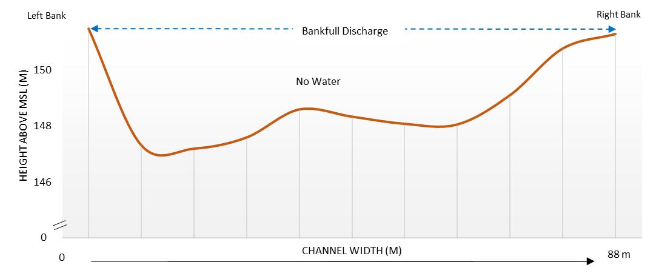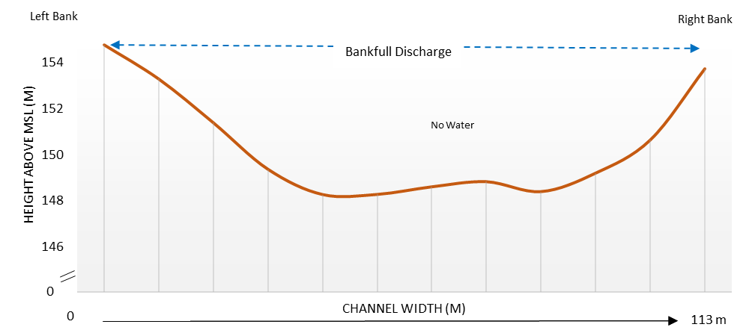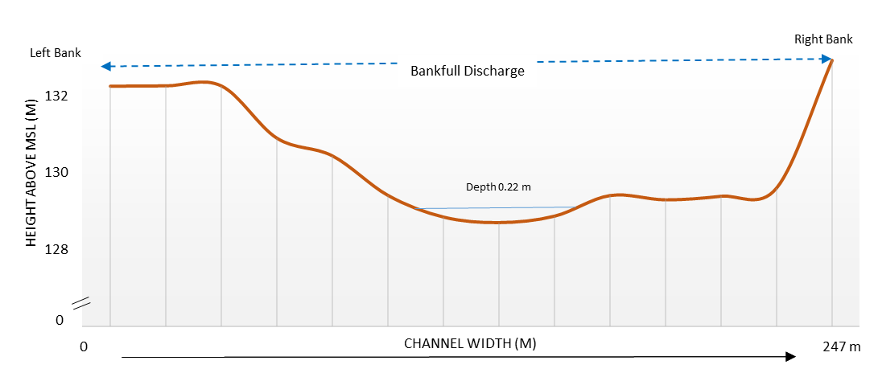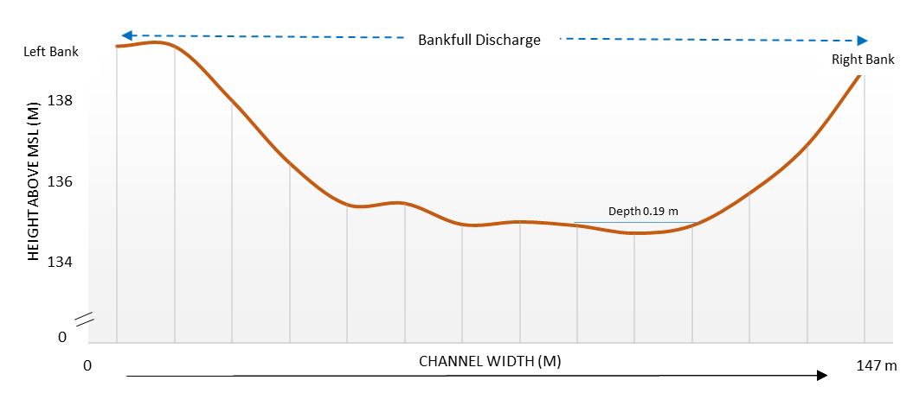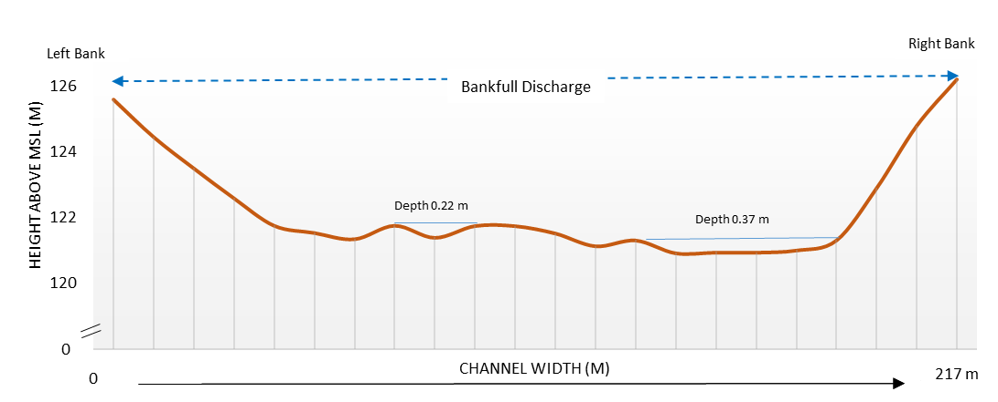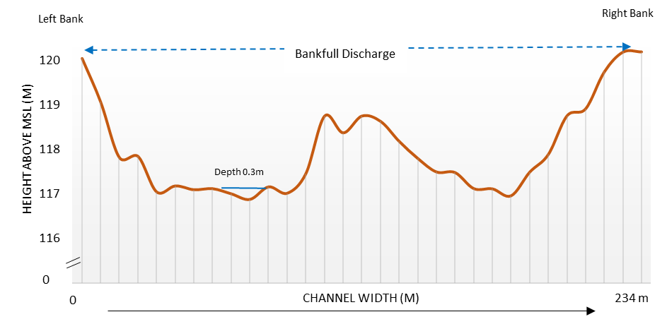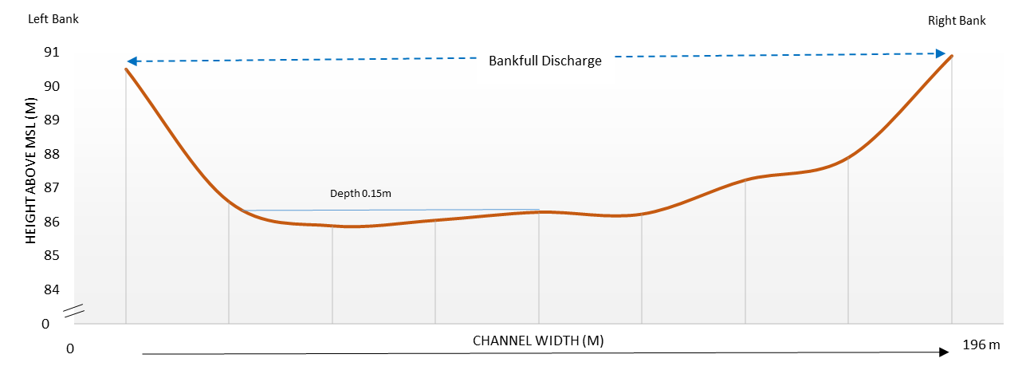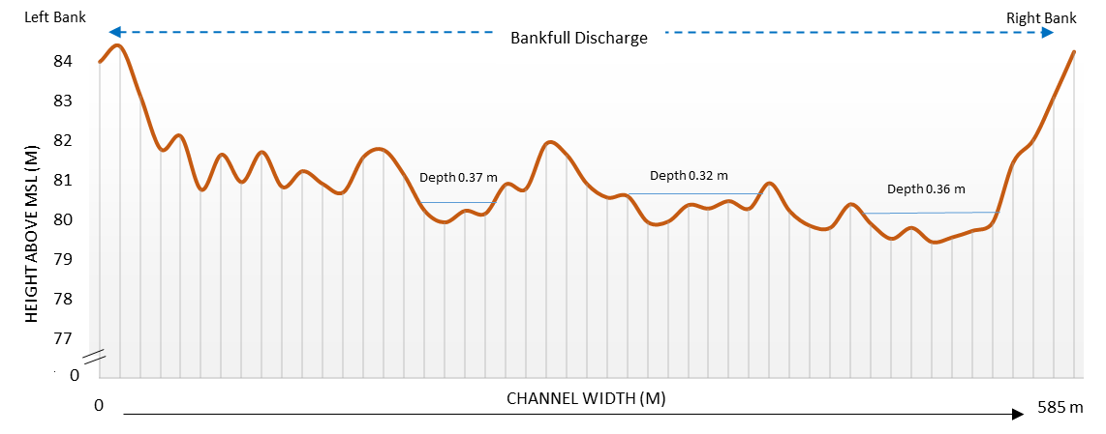

**Fig. 5** Channel configuration of 14 different cross-sectional sites of the Mayurakshi River Basin (**a**) Amarpur right branch (CS 1), (**b**) Amarpur left branch (CS 2), (**c**) Asanjor (CS 3), (**d**) Maharo (CS 4), (**e**) Dudhani (CS 5), (**f**) Poljori (CS 6), (**g**) Banskuli (CS 7), (**h**) Beniagram (CS 8), (**i**) Diguli (CS 9), (**j**) Ajaypur right branch (CS 10), (**k**) Ajaypur left branch (CS 11), (**l**) Sainthia (CS 12), (**m**) Panjona (CS 13), (**n**) Sundarpur (CS 14)

(a)

(b)

(c)

(d)

(e)

(f)

(g)

(h)

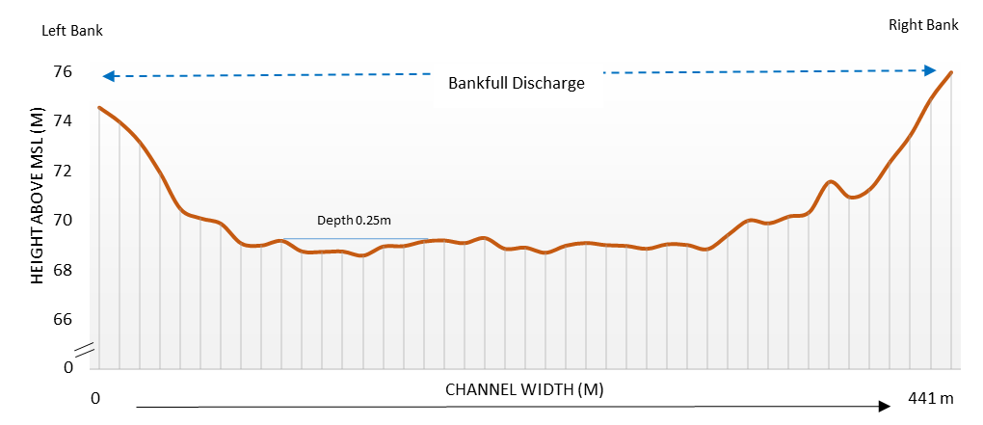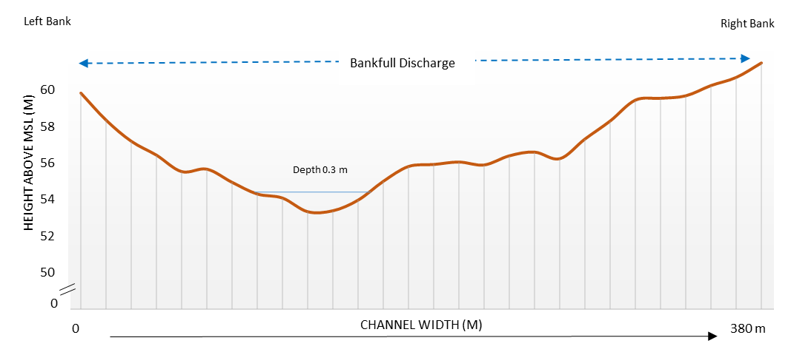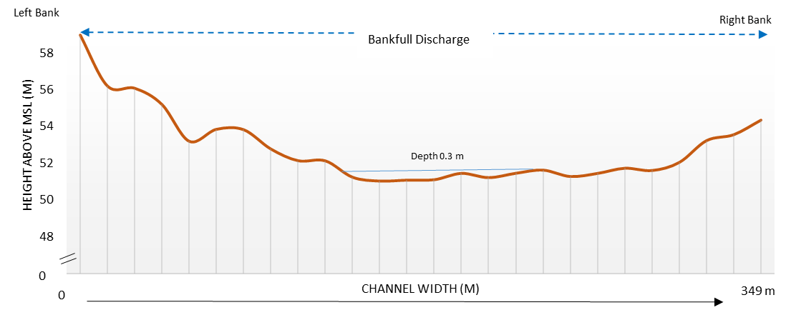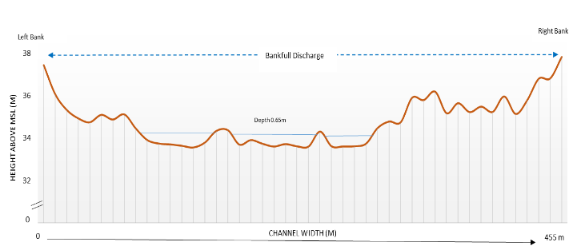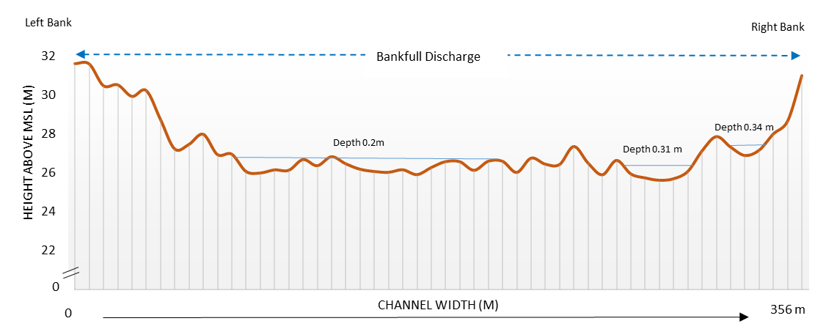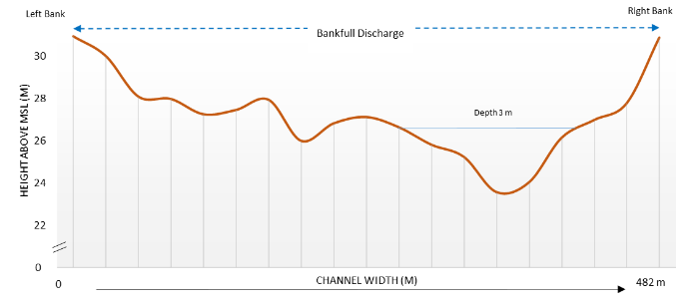

**Fig. 5** Continued

(i)

(j)

(k)

(l)

(m)

(n)

**Table 1** Important geometrical character of cross-sectional sites of the Mayurakshi River Basin during Post-Monsoon season

|  |  |  |  |  |  |  |  |  |  |  |  |  |  |  |
| --- | --- | --- | --- | --- | --- | --- | --- | --- | --- | --- | --- | --- | --- | --- |
| Sl No | Course | Location | Total channel width (in m) | Total flow width (in m) | Bank to thalweg width (in m) | | Channel Depth (in m) (Bank to Bank) | | Maximum depth of Water (in m) | Longitudinal Slope (in %) | Wetted Perimeter (in m) | Hydraulic Radius (in m) | Total flow area (in sq. m) | Total channel area (in sq. m) |
| From left bank | From right bank | Maximum | Average |
| 1 | Upper course | Amarpur right branch | 88 | No Water | No Water | | 4.09 | 2.18 | No Water | 0.22 | No Water | No Water | No Water | 283.72 |
| 2 | Amarpur left branch | 113 | No Water | 4.50 | 2.44 | No Water | 0.22 | No Water | No Water | No Water | 385.38 |
| 3 | Asanjor | 147 | 42 | 105 | 42 | 2.99 | 1.45 | 0.19 | 0.2 | 41.38 | 0.095 | 3.93 | 147 |
| 4 | Maharo | 247 | 16.7 | 63 | 184 | 2.21 | 0.73 | 0.22 | 0.3 | 16.70 | 0.110 | 1.84 | 247 |
| 5 | Dudhani | 217 | 69 | 69 | 148 | 4.67 | 3.30 | 0.37 | 0.03 | 69.05 | 0.266 | 18.39 | 217 |
| 6 | Poljori | 234 | 37 | 65 | 169 | 2.69 | 1.36 | 0.30 | 0.03 | 37.33 | 0.286 | 10.66 | 234 |
| 7 | Middle course | Banskuli | 196 | 28 | 25 | 171 | 4.62 | 2.99 | 0.15 | 0.2 | 28.33 | 0.075 | 2.12 | 196 |
| 8 | Beniagram | 585 | 183 | 253 | 332 | 4.57 | 3.03 | 0.37 | 0.02 | 182.88 | 0.303 | 55.46 | 585 |
| 9 | Diguli | 441 | 113 | 56 | 385 | 5.97 | 4.34 | 0.25 | 0.06 | 112.90 | 0.203 | 22.88 | 441 |
| 10 | Ajaypur right branch | 380 | 48 | 106 | 274 | 6.43 | 2.98 | 0.30 | 0.01 | 48.12 | 0.258 | 12.42 | 380 |
| 11 | Ajaypur left branch | 349 | 49 | 191 | 158 | 7.92 | 6.12 | 0.30 | 0.01 | 49.56 | 0.232 | 11.48 | 349 |
| 12 | Sainthia | 455 | 98 | 180 | 275 | 3.88 | 2.54 | 0.65 | 0.01 | 98.60 | 0.446 | 44.02 | 455 |
| 13 | Lower course | Panjona | 356 | 164 | 261 | 95 | 5.39 | 3.80 | 0.34 | 0.03 | 164.05 | 0.295 | 48.44 | 356 |
| 14 | Sundarpur | 482 | 54 | 465 | 17 | 7.31 | 3.58 | 3.0 | 0.01 | 54.53 | 1.952 | 106.46 | 482 |

Source: Computed by authors

upper course of a channel but in case of this study, an inverse picture has been noticed. With increasing distance from the upstream to downstream, the value of hydraulic radius gradually increases, also shows a positive trend (r2= 0.42) (Fig. 5g). This shows the downstream of the river is more efficient in terms of greater amount of discharge of water. Similarly, the relation between cross-sectional flow area with hydraulic radius shows a very strong positive co-relation (r2= 0.77) (Fig. 5f).

The location near Sundarpur (CS 14), the river flow path is highly modified by human activities. People have restricted the natural flow of river by impounding various structures like large pipes, boulders and utilise the river water for brick kilns industries, fishing activities etc. As a result, the channel flow area and the flow velocity has artificially increased and portray a paradoxical scenario of the river.

**3.1.4 Velocity distribution**

During lean period of study, the flow velocity of the Mayurakshi River is not uniformly distributed throughout the channel. Not only the flat broader channel shape, there are some other considerations for which the inconsistency in flow velocity pattern has been observed. The data retrieved from the field study using current meter shows, the average velocity of the upstream section of the river is very low than the lower reach of the river. In Asanjor (CS 3), the depth of water is very minimum (0.19 m) for which the hydraulic radius become low and because of the higher surface roughness, the velocity of the channel has reduced to 0.223 m/sec (Table 2). Whereas in Dudhani (CS 5) and Diguli (CS 9), the middle and lower reach of the river shows a comparatively high average velocity i.e., 0.37 m/sec and 0.43m/sec respectively. In this region, the flow momentum of the river got also affected by the huge downpouring of water to the Mayurakshi River via its tributaries like Tepra and Siddheswari. These two rivers carry huge volume of water during monsoon season and create a flood like situation near the adjoining areas of the Mayurakshi River (Pal and Debanshi 2017). Next to this, Poljori (CS 6), just above the Massanjore Dam, the velocity of river water reduces significantly (0.11m/sec) as a result of stagnant water with no flow condition. But from the area down below the Tilpara Barrage, the average flow velocity of the channel has been increased significantly. At Sundarpur (CS 14), due to an abrupt increase of hydraulic radius, the flow velocity increases significantly upto 0.85 m/s. Although the non-uniformity of the velocity distribution throughout the river is catalysed by the presence of bridges in Sainthia (CS 12), sand heap formation in the river bed near Asanjor (CS 3), Banskuli (CS 7), Sainthia (CS 12) and confine the normal shape and flow of the river.

**3.2 Application of hydraulic and hydrological model for discharge estimation**

In this study, the estimation of lean period discharge has been presented in a three-way - field observed discharge data, calculated discharge using two important model- Manning’s method and Kinematic Wave Parameter (KWP) method. These two methods have been taken into consideration as it includes the in-stream channel geometry, channel roughness, longitudinal slope and also the amount of rainfall which are mainly responsible for the generation of runoff contributing discharge over an area (Roy 2013).

Fig 6. Relationship study between the important channel geometric parameter (a) Distance vs channel width (b) Distance vs maximum channel depth (c) Channel width vs channel depth (d) Distance vs total channel area (e) Distance vs total flow area (f) Flow area vs hydraulic radius (g) Distance vs hydraulic radius

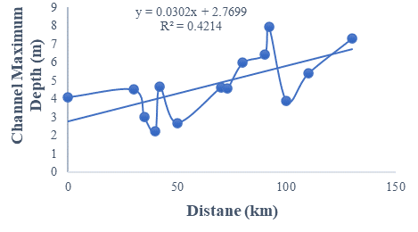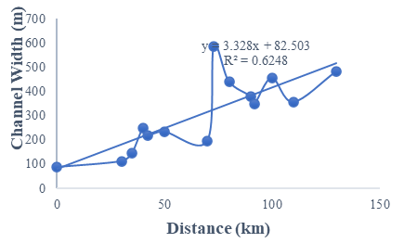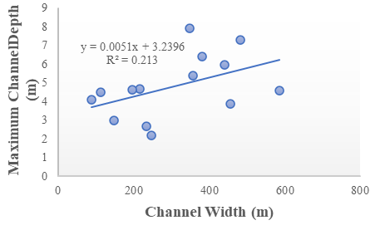

(a)

(b)

(c)

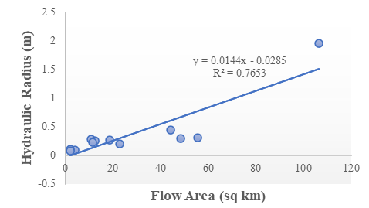

(f)

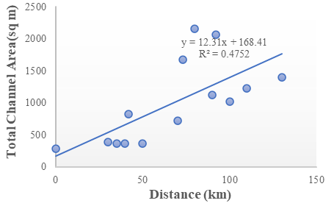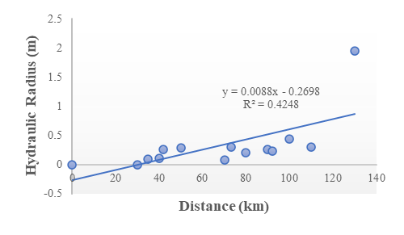

(g)

(d)

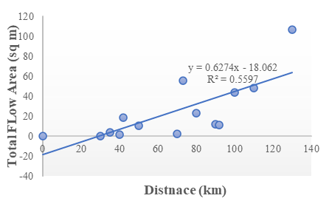

(e)

(f)

* + 1. **Estimation of discharge from field survey**

Table 2 shows field observed discharge data for the selected 14 cross sections of the Mayurakshi River. This method of discharge estimation consists of the measuring the area of cross-section and the velocity using current meter. The entire river cross-section has been divided into n numbers of small trapezoids and the cross-section area of a channel has been determined using the trapezoidal rule. Applying such area-velocity or standard current meter method (Subramanya 2008), the volume of flow discharged from different sites of the Mayurakshi River during post-monsoon period has been calculated which shows a considerable increase in discharge mainly in downstream of the river. As the lower reach of the Mayurakshi River receives a huge volume of water from the tributaries like Kuya, Dwaraka, the lean period discharge of water near the Panjona (CS 13) and Sundarpur (CS 14) experiences an increase in river discharge upto 90.9 cumec and 26.9 cumec respectively. A significant increase in the volume of water has also been noticed in Beniagram (CS 8), located just below the Massanjore Dam. A huge release of water from the dam makes the channel flow width effectively wider (183 m) and escalate the discharge (13.25 m3/sec) of water from the channel.

**Table 2** Lean period velocity measurement using current meter at different cross-sections of the Mayurakshi River

|  |  |  |  |  |  |
| --- | --- | --- | --- | --- | --- |
| Sl No | Course | Location | Area of Flow (in sq. m) | Measured Average Velocity (in m/sec) | Discharge (in m3/s) |
| 1 | Upper course | Amarpur right branch | No Water | | |
| 2 | Amarpur left branch |
| 3 | Asanjor | 3.93 | 0.223 | 0.877 |
| 4 | Maharo | 1.84 | 0.38 | 0.698 |
| 5 | Dudhani | 18.39 | 0.371 | 6.822 |
| 6 | Poljori | 10.66 | 0.114 | 1.216 |
| 7 | Middle course | Banskuli | 2.12 | 0.225 | 0.478 |
| 8 | Beniagram | 55.46 | 0.239 | 13.254 |
| 9 | Diguli | 22.88 | 0.428 | 9.791 |
| 10 | Ajaypur right branch | 12.42 | 0.187 | 2.322 |
| 11 | Ajaypur left branch | 11.48 | 0.196 | 2.249 |
| 12 | Sainthia | 44.02 | 0.263 | 11.577 |
| 13 | Lower course | Panjona | 48.44 | 0.556 | 26.933 |
| 14 | Sundarpur | 106.46 | 0.854 | 90.918 |

Source: Field survey

* + 1. **Estimation of discharge using Manning’s equation method**

Table 3 shows the required parameters for calculating river discharge using Manning’s equation. It is the most important hydraulic model that consists the estimation of hydraulic radius and wetted perimeter of each section. Another important consideration of Manning’s equation is the channel roughness co-efficient. The uniqueness of this work is lied on calculating the Manning’s ‘factor using the channel friction factor and equivalent sand roughness instead of selecting the ‘n’ value from the table given by Chow (1964). All these parameters have been calculated using various convenient equations as mentioned in the methodology section. The result of this study has significantly coincided with the field observed discharge data with a little variation. In CS 5 (Dudhani), the Manning’s derived discharge is 18.39 cumec where the field observed data shows 6.82 cumec volume of water passes during post-monsoon season. Similarly in a downstream location like in CS 13 (Panjona) the observed discharge is 26.33 m3/s and the calculated discharge shows a slightly higher value of 48.44 m3/s in a lean period of study.

* + 1. **Estimation of discharge using Kinematic Wave Parameter (KWP) method**

It is a major hydrological model which is totally based on the amount of rainfall intensity, generating the surface runoff as discharge over the river basin area. As the field has been carried out on a post monsoon month of December, authors have calculated the rainfall intensity in cm/h based on those corresponding 31 days daily rainfall data. Table 4 represent the result of discharge estimation using this method which shows a comparative higher value of discharge from the field observed measurements. For example, in Beniagram (CS 8) the estimated discharge from Kinematic Wave equation is 23.37 m3/s, whereas in case field observed discharge data shows 13.25 m3/s.

**Table 3** Lean period discharge estimation of different cross section sites of the Mayurakshi River using Manning’s equation

|  |  |  |  |  |  |  |  |  |
| --- | --- | --- | --- | --- | --- | --- | --- | --- |
| Sl No | Course | Location of Cross-Section | Longitudinal Slope (in %) | Area of Flow (in sq. m) | Hydraulic Radius (in m) | Manning’s Roughness Co-efficient | Manning’s Velocity (in m/sec) | Discharge (in m3/s) |
| 1 | Upper course | Amarpur right branch | 0.22 | No Water | | | | |
| 2 | Amarpur left branch | 0.22 |
| 3 | Asanjor | 0.2 | 3.93 | 0.2 | 3.93 | 0.2 | 3.93 |
| 4 | Maharo | 0.3 | 1.84 | 0.3 | 1.84 | 0.3 | 1.84 |
| 5 | Dudhani | 0.03 | 18.39 | 0.03 | 18.39 | 0.03 | 18.39 |
| 6 | Poljori | 0.03 | 10.66 | 0.03 | 10.66 | 0.03 | 10.66 |
| 7 | Middle course | Banskuli | 0.2 | 2.12 | 0.2 | 2.12 | 0.2 | 2.12 |
| 8 | Beniagram | 0.02 | 55.46 | 0.02 | 55.46 | 0.02 | 55.46 |
| 9 | Diguli | 0.06 | 22.88 | 0.06 | 22.88 | 0.06 | 22.88 |
| 10 | Ajaypur right branch | 0.01 | 12.42 | 0.01 | 12.42 | 0.01 | 12.42 |
| 11 | Ajaypur left branch | 0.01 | 11.48 | 0.01 | 11.48 | 0.01 | 11.48 |
| 12 | Sainthia | 0.01 | 44.02 | 0.01 | 44.02 | 0.01 | 44.02 |
| 13 | Lower course | Panjona | 0.03 | 48.44 | 0.03 | 48.44 | 0.03 | 48.44 |
| 14 | Sundarpur | 0.01 | 106.46 | 0.01 | 106.46 | 0.01 | 106.46 |

Source: Computed by authors

**Table 4** Lean period discharge estimation of different cross section sites of the Mayurakshi River using Kinematic Wave Parameter (KWP) equation

|  |  |  |  |  |  |  |  |  |  |
| --- | --- | --- | --- | --- | --- | --- | --- | --- | --- |
| Sl No | Course | Location of Cross-Section | Contributing Drainage Basin Area (in sq. km) | Intensity of Rainfall (in cm/hr) | Longitudinal Slope (in %) | Manning’s Roughness Co-efficient | Mean Flow Width of the channel (in m) | Flow Velocity (in m/sec) | Discharge (in m3/s) |
| 1 | Upper course | Amarpur right branch | 466 | 0.05 | 0.22 | No Water | | | |
| 2 | Amarpur left branch | 485 | 0.05 | 0.22 |
| 3 | Asanjor | 684 | 0.05 | 0.2 | 0.0212 | 42 | 0.9502 | 3.74 |
| 4 | Maharo | 917 | 0.05 | 0.3 | 0.0196 | 16.7 | 1.8346 | 3.37 |
| 5 | Dudhani | 1385 | 0.05 | 0.03 | 0.0182 | 69 | 0.6412 | 11.79 |
| 6 | Poljori | 1437.98 | 0.05 | 0.03 | 0.0184 | 37 | 0.8315 | 8.87 |
| 7 | Middle course | Banskuli | 811.46 | 0.028 | 0.2 | 0.0198 | 28 | 0.9893 | 2.10 |
| 8 | Beniagram | 2807 | 0.028 | 0.02 | 0.0169 | 183 | 0.4215 | 23.37 |
| 9 | Diguli | 2886 | 0.016 | 0.06 | 0.0165 | 112.85 | 0.5842 | 13.37 |
| 10 | Ajaypur right branch | 1560 | 0.016 | 0.01 | 0.0152 | 48 | 0.3953 | 4.91 |
| 11 | Ajaypur left branch | 1560 | 0.016 | 0.01 | 0.0146 | 49 | 0.4019 | 4.61 |
| 12 | Sainthia | 3168 | 0.016 | 0.01 | 0.0152 | 98 | 0.3936 | 17.34 |
| 13 | Lower course | Panjona | 3205 | 0.0042 | 0.03 | 0.0143 | 164 | 0.2716 | 13.16 |
| 14 | Sundarpur | 1293 | 0.049 | 0.01 | 0.0164 | 54 | 0.5230 | 55.68 |

Source: Computed by authors

**Fig. 7** Comparison between the applied models with respect to the field observed discharge data in the Mayurakshi River

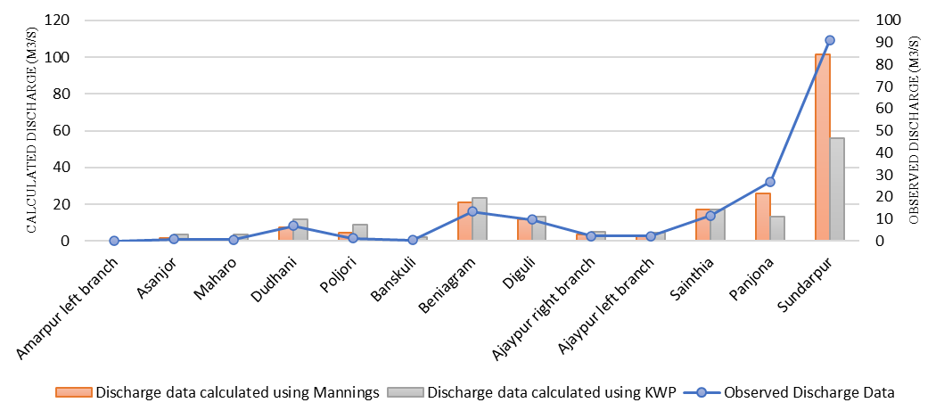

**3.3 Model performance evaluation**

In this section, authors compared all these calculated data derived from Manning’s equation and Kinematic Wave parameter method, with the observed data collected during the field study conducted in post monsoon season. As shown in Figure 7, the data calculated with Manning's equation give better results than the data estimated with Kinematic Wave Parameter method. Furthermore, to identify the best method with the least error function, Root of Mean Square Error (RMSE) has been calculated using field data as observed value and classical algorithm data as predicted value. It has been proved from the result (Table 5) that the Manning’s formula has minimum error and can be scientifically accepted to estimate lean period flow amount within a section of a tropical river in a cost-effective way.

**Table 5** Result of applied model’s performance using Root Mean Square Error calculation

|  |  |
| --- | --- |
| Applied models | RMSE in % |
| Manning’s equation | 30.53 |
| Kinematic Wave Parameter | 85.28 |

Source: Computed by authors

1. **Conclusion**

The Mayurakshi Reservoir Project and Canal Irrigation System, initiated by the Bengal Government with financial assistance from the Canadian Government (Annual Flood Report 2016), provides a large amount of water to the residents of Birbhum, Bardhaman, Murshidabad and Jharkhand. The increase in human intervention is causing deterioration of channel geomorphology and disruption of natural river flow. In this way, the channel becomes inefficient and creates paradoxical situations in terms of its width, depth, water content, flow velocity, and discharge. The present study demonstrates that, width and depth of the cross profiles in Mayurakshi River does not follow the normal pattern of hydrology. In the upper part of the channel, the width is wider than usual because of the Massanjore Dam and Tilpara Barrage. Furthermore, the successive addition of water by the tributaries enhances the flow momentum and increases the depth of the flow in the main river's lower reaches.The authors have also estimated the post monsoon flow velocity and discharge amount in Mayurakshi River. In case of velocity, it shows an increasing trend (0.52 m/sec near Sundarpur) towards downstream of the river. Likewise, the volume of water gets discharged during the lean period from each cross-section has also been evaluated. Authors have compared the field observed discharge data with two hydraulic and hydrological model namely Manning’s equation and Kinematic Wave Parameter (KWP) and the study reveals that that Manning’s equation-based model has the minimum error function (RMSE=28.04%) for the estimation of discharge in a lean period. Compared to Kinematic Wave method, it gives the closest result to the observed field discharge value. Kinetic wave Parameter is a rainfall based hydrological model which relies heavily on rainfall intensity. Due to low effective rainfall (total rainfall-infiltration loss) during the post monsoon season, total rainfall has been used to calculate rainfall intensity for the Mayurakshi River basin. Therefore, the calculated discharge from Kinematic Wave model has a higher value than the measured discharge from field study.  However, despite some errors in the models, the major objective of this study has been achieved and the hydro-geomorphological behavior of Mayurakshi River has been illustrated.

 In a tropical country like India, rainfall is very erratic in nature, so larger water storage dams and reservoirs are constructed not only to control the flood but also to regulate the downstream river flow and water supply during non-monsoonal seasons by providing a variety of services to meet human demands for water. Groundwater is being over-exploited in many places of the country to meet the growing food demand. During dry months, the base flow of the river are lowered by falling groundwater tables. During the lean period, river flows have not been adequate to meet irrigational needs in that area, ultimately destroying the entire hydrological system. Therefore, there is a need to study the available water resources during the lean period to maintain riparian ecology and environment healthy for human beings. It will also be beneficial for the planners to estimate the channel capacity to hold the heavy flow during monsoon by minimizing the effect of flood. Additionally, such hydrological models are useful not just in ungauged rivers, but also in gauge-based rivers. The worldwide acceptability and the easy use of such geomorphic based approach may become a useful tool in a scientific study of open channel flow dynamics.

**Statements and Declarations**

**Funding**

No funds or grants were received during the preparation of this manuscript.

**Competing interests**

The authors declare that they have no conflict of interest to disclose.

**Availability of data and material**

All data generated or analysed during this study are included within the manuscript.

**Code availability**

(Not applicable)

**Authors' contributions**

All the authors have contributed to design the manuscript. The data preparation and calculation has been done by Sayak Karmakar and Swetasree Nag. The first draft of the manuscript has been written by Swetasree Nag and reviewed by Sayak Karmakar. Pankaj Kumar Roy and Malabika Biswas Roy have gone through the entire manuscript for necessary modifications. All authors read and approve the final manuscript.

**References**

* Annual flood report (2016) Irrigation and waterways directorate. Government of West Bengal. https ://wbiwd .gov.in/uploa ds/ANNUAL_FLOOD REPOR T_2016.pdf. Accessed 13th Nov 2022
* Basu SR, Ghosh A, De SK (2005) Meandering and cut-off of the river Bhagirathi. Geomorphology and environmental sustainability. Concept Publishing Company, New Delhi, pp 20–37
* Bjerklie DM, Dingman SL, Vorosmarty CJ, Bolster CH, Congalton RG (2003) Evaluating the potential for measuring river discharge from space. J. Hydrol 278, 17–38.
* Bloom L (2009) Geomorphology, a Systematic Analysis of Late Cenozoic Landforms, PHI Learning Private, New Delhi, India, 3rd edition.
* Chaudhry MH (1993) Open-Channel Flow.  Prentice-Hall, Inc.
* Chaudhury AK (1966) On the meteorological conditions responsible for heavy rainfall in Ajay catchment Area. Indian J Meteorol Geophys. 17:127–132
* Chow VT (1959) Open-Channel Hydraulics, McGraw-Hill, New York, NY, USA.
* Chow VT (1964) Handbook of Applied Hydrology, McGraw-Hill, New York, NY, USA.
* David A. Chin (2020) Water-resources Engineering. 4th Edition, Pearson Prentice Hall publisher, United States of America.
* Getirana ACV, Bonnet MP, Calmant S, Roux E, Rotunno OC, Mansur WJ (2009) Hydrological monitoring of poorly gauged basins based on rainfall-runoff modeling and spatial altimetry. J. Hydrol 379, 205–219
* Ghosh S, Guchhait SK (2016) Dam-induced changes in flood hydrology and flood frequency of tropical river: a study in Damodar River of West Bengal, India. Arab J Geosci 9(2):90
* Hoque MM, Islam A, Ghosh S (2022) Environmental flow in the context of dams and development with special reference to the Damodar Valley Project, India: a review. Sustain. Water Resour. Manag.  <https://doi.org/10.1007/s40899-022-00646-9>
* Islam A, Sarkar B (2021) Analysing flood history and simulating the nature of future floods using Gumbel method and Log-Pearson Type III: The case of the Mayurakshi River Basin, India. Bulletin of Geography. Physical Geography Series. 19. 43-69. 10.2478/bgeo-2020-0009.
* Iturbe R, Devoto G, Valdes JB (1979) Discharge response analysis and hydrologic similarity: the interrelation between the geomorphologic IUH and the storm characteristics. Water Resources Research. vol. 15, no. 6, pp. 1435–1444.
* Jain SK, Kumar P (2014) Environmental flows in India: towards sustainable water management. Hydrological Sciences Journal. 59:3-4, 751-769, DOI: 10.1080/02626667.2014.896996
* K. Subramanya (2008) Engineering Hydrology. 3rd Edition, Tata McGraw-Hill Publishing, New Delhi
* Knight DW, McGahey C, Lamb R, Samuels PG (2010) Practical Channel Hydraulics. CRC Press Inc. Boca Raton, FL.
* Knighton AD (1998) Fluvial forms and processes. Oxford univ press, Inc., New York, USA
* Leopold LB, Wolman MG, Millar JP (1964) Fluvial processes in geomorphology. Eurasia publishing house (Pvt.) ltd. Ram Nagar. New Delhi 55:161
* Lord ML, Germanaski D, Allmandinger NE (2009) Fluvial geomorphology: monitoring stream systems in response to a changing environment. The Geol Soc of Am. 69–103
* Manning R (1891) On the flow of water in open channels and pipes. Transactions of the Institution of Civil Engineers of Ireland, vol. 20, pp. 161–207.
* Mc Manamay RA, Bevelhimer MS (2013) A Holistic framework for environmental flows determination in hydro-power contexts. Oak Ridge National Laboratory, Oak Ridge. <http://www.osti.gov/bridge>
* Mistry RE (1972) Navigational problems and hazards in the port of Calcuta. In: The Bhagirathi-Hooghly Basin—proceedings of the interdisciplinary symposium, pp 168–173
* Mitra S, Singh A (2018) Assessment of environmental flow requirements of Damodar River basins by using flow duration indices method – a case study. Int J Hydrol 2(3):281–283
* Mohammadi H, Ahmadi E, Taghvaye S, Khalighi Sh, Sallajegheh A (2012) Regional model presentation for peak discharge estimation in ungauged drainage basin using geomorphologic, Synyder, SCS and triangular models (case study: Kan drainage basin). Caspian Journal of Environmental Sciences, vol. 10, no. 1, pp. 91–102.
* Mondal M, Ghosh S, Satpati LN (2018) Optimum cross section index (OCI): a new approach for identification of an optimum channel—a case study of the Ichamati River, India. Arab J Geosci. 11, 333 <https://doi.org/10.1007/s12517-018-3667-3>
* Nag S, Roy MB, Roy PK (2022) Study on the functionality of land use land cover over the evaluation of groundwater potential zone: A fuzzy AHP based approach. J Earth Syst Sci 131-146 <https://doi.org/10.1007/s12040-022-01872-7>
* Pal S (2016) Impact of Massanjore dam on hydro-geomorphological modification of Mayurakshi river, Eastern India. Environ Dev Sustain 18(3):921–944
* Pal S, Debanshi S (2017) Influences of soil erosion susceptibility toward overloading vulnerability of the gully head bundhs in Mayurakshi River basin of eastern Chottanagpur Plateau. Environ Dev Sustain 20(4):1739–1775
* Pandey R, Ramasastri KS (2003) Estimation of lean season water availability in streams with limited data. Journal of the Institution of Engineers (India): Civil Engineering Division. 84. 149-152.
* Petts GE (1979) Complex response of river channel morphology subsequent to reservoir construction. Prog Phys Geogr 3(3):329–362
* Raúl L, Barragan J (2008) Equivalent Roughness of Gravel-Bed Rivers. Journal of Hydraulic Engineering. 134. 847-851. 10.1061/(ASCE)0733-9429(2008)134:6(847).
* Richards KS (1982) Rivers, form and process in alluvial channels. Methuen, London
* Roy S (2013) Estimation of Peak Flood Discharge for an Ungauged River: A Case Study of the Kunur River, West Bengal. Geography Journal. https://doi.org/10.1155/2013/214140.
* Sen PK (1993) Geomorphological analysis of drainage basins. Univ of Burdwan Burdwan: 5
* Sichangi AW, Wang L, Yang K, Chen D, Wang Z, Li X, Zhou J (2016) Estimating continental river basin discharges using multiple remote sensing data sets. Remote Sens. Environ 179, 36–53.
* Singh VP (2003) On the theories of hydraulic geometry. Int J of Sediment Res 18(3):196–218
* SparksBW (1960) Geomorphology, Longmans Green, London: 76–99
* Summerfield MA (1991) Global Geomorphology: An Introduction to the Study of Landform, Pearson Education, Edinburgh, UK, 1st edition.
* Swamee PK, Mishra GC, Chahar BR (2000) Comprehensive design of minimum cost irrigation cannel sections. J of Irri and Drainage Eng 200:322–327
* Tabata KK, Hickin EJ (2003) Interchannel hydraulic geometry and hydraulic efficiency of the anastomosing Columbia River, southeastern British Columbia, Canada. Earth Surf Process Landf J Br Geomorphol Res Group 28(8):837–852
* Williams GP, Wolman MG (1984) Downstream effects of dams on alluvial rivers, vol 1286. US Government Printing Office, Washington
* Xu M, Kang S, Chen X, Wu H, Wang X, Su Z (2018) Detection of hydrological variations and their impacts on vegetation from multiple satellite observations in the Three-River Source Region of the Tibetan Plateau. Sci. Total Environ 639, 1220–1232.
* Yang S, Wang J, Wang P, Gong T, Liu H (2019) Low Altitude Unmanned Aerial Vehicles (UAVs) and Satellite Remote Sensing Are Used to Calculated River Discharge Attenuation Coefficients of Ungauged Catchments in Arid Desert. Water 11, 2633.
* Yen C (2002) Open channel flow resistance. Journal of Hydraulic Engineering, vol. 128, no. 1, pp. 20–39.